Final Assessment-Alternative Assessment
Semester | 202520 | Division | CIS
Assessment title in Syllabus | Final_Project_Portfolio | Program | Bachelor of Information Technology/ Bachelor of Information Systems
Course Code | CDS 2413
Course Title | INTRODUCTION TO DATA SCIENCE
Course Instructor |  | CRN
Assessment | Project Deliverable 1 – Data Analysis Report | Submission Date | Week 6
Student Declaration:
Academic Integrity Statement
In accordance with the HCT Academic Integrity Policy
• Students are required to refrain from all forms of academic integrity breaches as defined and explained by HCT.
• A student found guilty of having committed acts of academic integrity breach(es) will be subject to the relevant sanctions as outlined by HCT.
إفادة النزاهة الأكاديمية
وفقًا لسياسة كليات التقنية العليا للنزاهة الأكاديمية
• على الطلبة الإلتزام بلوائح وقواعد النزاهة الأكاديمية، كما هو مبيّن وموضح في السياسات والإجراءات الخاصة بكليات التقنية العليا.
• في حالة ارتكاب الطالب أي شكل من أشكال الإخلال بالنزاهة الأكاديمية، سيتعرض الى العقوبات الموضحة في السياسات ذات الصلة.
This assignment is entirely my/our own work except where I have duly acknowledged other sources in the text and listed those sources at the end of the assignment. I have not previously submitted this work to the HCT, or any other entity. I understand that I may be orally examined on my submission.

Student HCT ID(s): | H006019 | H00200 | H00 | H00
Student Name(s): | Roza Almansoori | Mahra Alremithi
Student Signature
Chatbot (e.g. ChatGPT) statement
This submission allows you to use AI generated tools, but the prompt used must be stated and the response must be in red font. Include References to ChatGPT.

Instructions

Remove instructions and hints from the template before submitting the final report to BBLearn.

CLO1: Introduction and Data Wrangling (5 Points)

Purpose of Data Analysis (1 point)
<< Define the purpose of data analysis for the chosen dataset >>.

Data analysis is defined as the process of inspecting, cleaning, transforming, and interpreting data in order to discover useful information and support decision-making (Week6 Data Processing)
The purpose of the dataset we chose for Kaggle is to study medical insurance costs and the factors that influence them. The goal of this analysis is to understand how different health indecatiors such as age, BMI, smoking status, number of children, sex and region may affect the overall insurance charges. This helps in identifying patterns and to support predicting insurance costs and understanding which factors have the greatest impact on charges

Type of Programming (1 point)
<< Identify and Justify the type of programming used for data analysis.>>

We used Python Programming language to perform the analysis it is widely used in data science because it provides powerful libraries such as pandas for data handling, NumPy for numerical operations and scikit-learn for machine learning tasks such as predicting insurance charges.
These tools will make the data analysis more efficient and support data visualization and interpretation of insurance cost patterns. they will also make it easier to manipulate large datasets and apply statistical techniques to identify how factors like age, BMI, and smoking status influence insurance costs

Type and Purpose of ML algorithm (1 point)
<< Identify the type and purpose of the machine learning algorithm to be implemented for the chosen dataset >>

The machine learning technique we used in this dataset is regression which is a method used to predict continuous numerical values rather than categories.
In our project regression is used to predict insurance charges based on different factors such as age, BMI, smoking status, number of children, sex and region. This will help us to understand how these independent variables influence the cost of medical insurance
Regression is suitable because the output variable that is the insurance charges is a continuous numerical value not categorical variable

Identify the Varaibles (1 point)
<< Identify and Justify the independent and dependent variables for the chosen dataset.>>

The dataset is divided into dependent and independent variables
- Dependent variables (y): Insurance charges: the variable we want to predict
- Independent variables (X): All other variabes such as age, BMI, smoking status, number of children, sex and region

According to data preprocessing steps the dataset is split into dependent and independent variables using Python techniques where the independent variables are used to explain and predict the dependent variable which is insurance charges

Sampling (1 point)
<< Will you do the sampling? Identify and Justify the type of sampling to be used for the chosen dataset.>>

Yes we will do sampling, it is an important step in data wrangling and helps to manage large datasets
In our project we are going to use two types of sampling:
- Random Sampling
Data is selected randomly to avoid bias and ensure fairness in representing insurance data patterns
- Systematic sampling
Data is selected in a system or a fixed way to mainatain consistency
Sampling reduces the time needed for analysis, improves efficiency and maintain reliable results when analyzing insurance charges

CLO2: Descriptive, Exploratory and Statistical Analysis (10 Points)

Purpose of Descriptive Analysis (1 point)
<< Justify why you want to perform the descriptive analysis for the chosen dataset. >>.

In general the descriptive statistics is used to summarize and describe the main features of the dataset. They help in simplifling large data into small understandable values and provide a clear overview of the dataset.
In this project we used descriptive analysis to understand how the values of the dependent variable and insurance charges are distributed and what charescterictics they have. This will help us to see patterns in the data, such are average charges, minimum and maximum values and how costs vary based on factors like age, BMI and smoking status. This makes the data easier to understand and support better analysis

Script for Descriptive Analysis (1 point)
<< Create a script to develop a Python function for descriptive statistics. The input for the function should be the sample an the field to perform the descriptive statistics..>>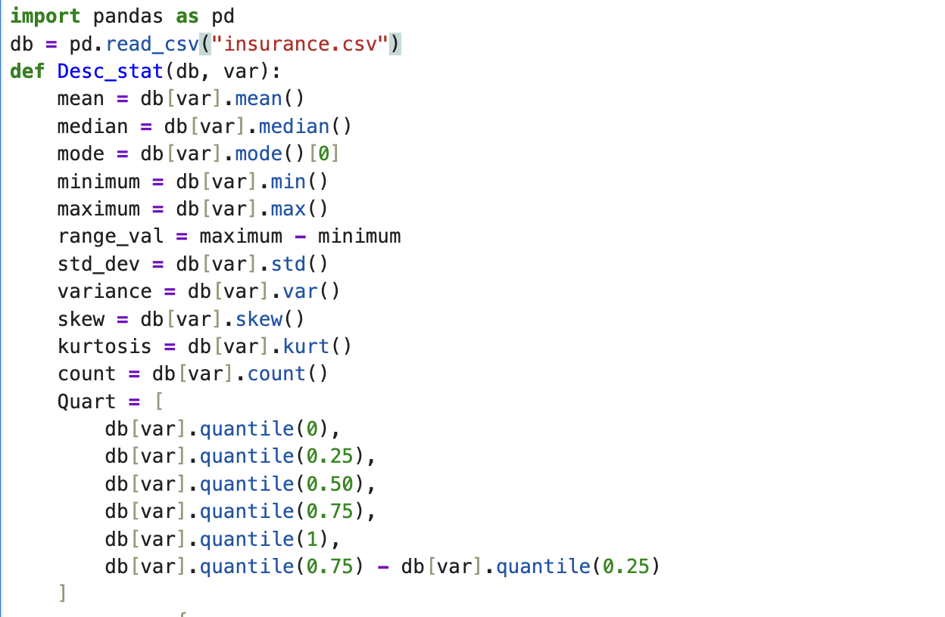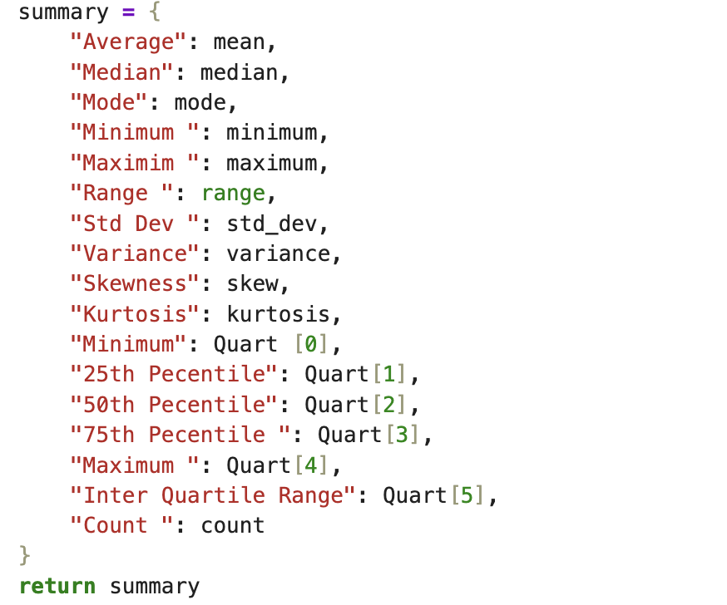d

Random Sampling (1 point)
<< Create a program to random sampling of size 150 and find the descriptive statistics for the dependent variable from the sample [Apply the descriptive function which you created].>>
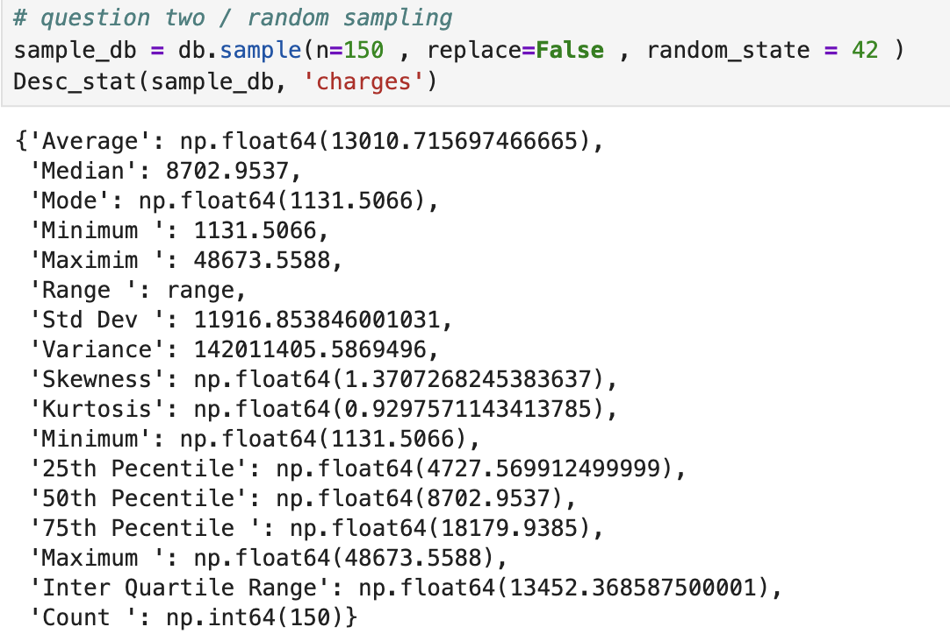

Systematic Sampling (1 point)
<< Create a script for systematic sampling by giving certain conditions and finding the desc stat for the dependent variable from the sample [Apply the descriptive function which you created]..>>

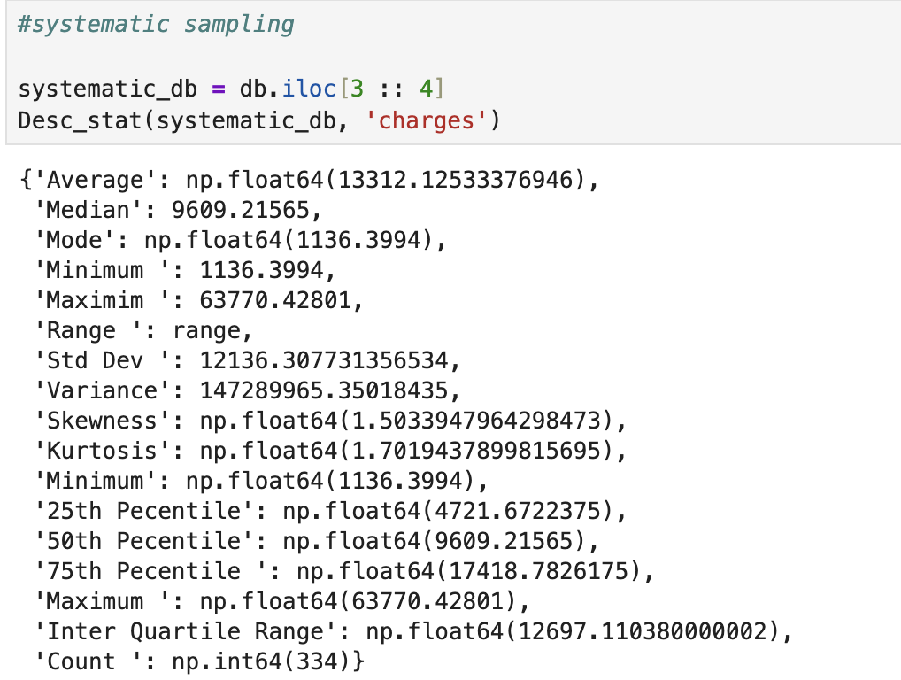

This code will create a sample by starting at the third index and chosing each forth row

Descriptive Statistical Report (1 point)
<< Create a detailed descriptive statistics report about the dependent variable of the chosen dataset.>>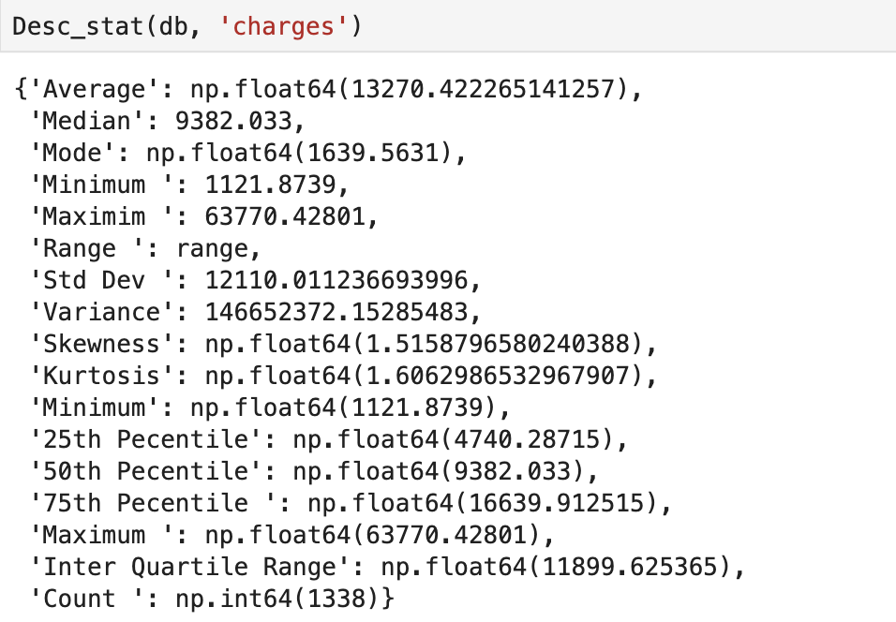
After making a python function to figure out the descriptive statistics for our dependent variable which is charges. We were able to figure out that the average insurance charge is 13,270 for the people in our study. The lowest insurance charge to be recorded is 1,121 while on the other hand the higgest price recorded is 63,770 which is a very big difference. The skewness tells us that the graph would be right skewed which means a high number of people have low insurance charges , while some people have high insurance charges which might be because of different variables such as if the person smokes , their age , bmi and much more

Visualisation through Various Charts (2 points)
- << Visualize the dependent variable by the Graph/Chart of the following using Python Program:
  - Scatter plot

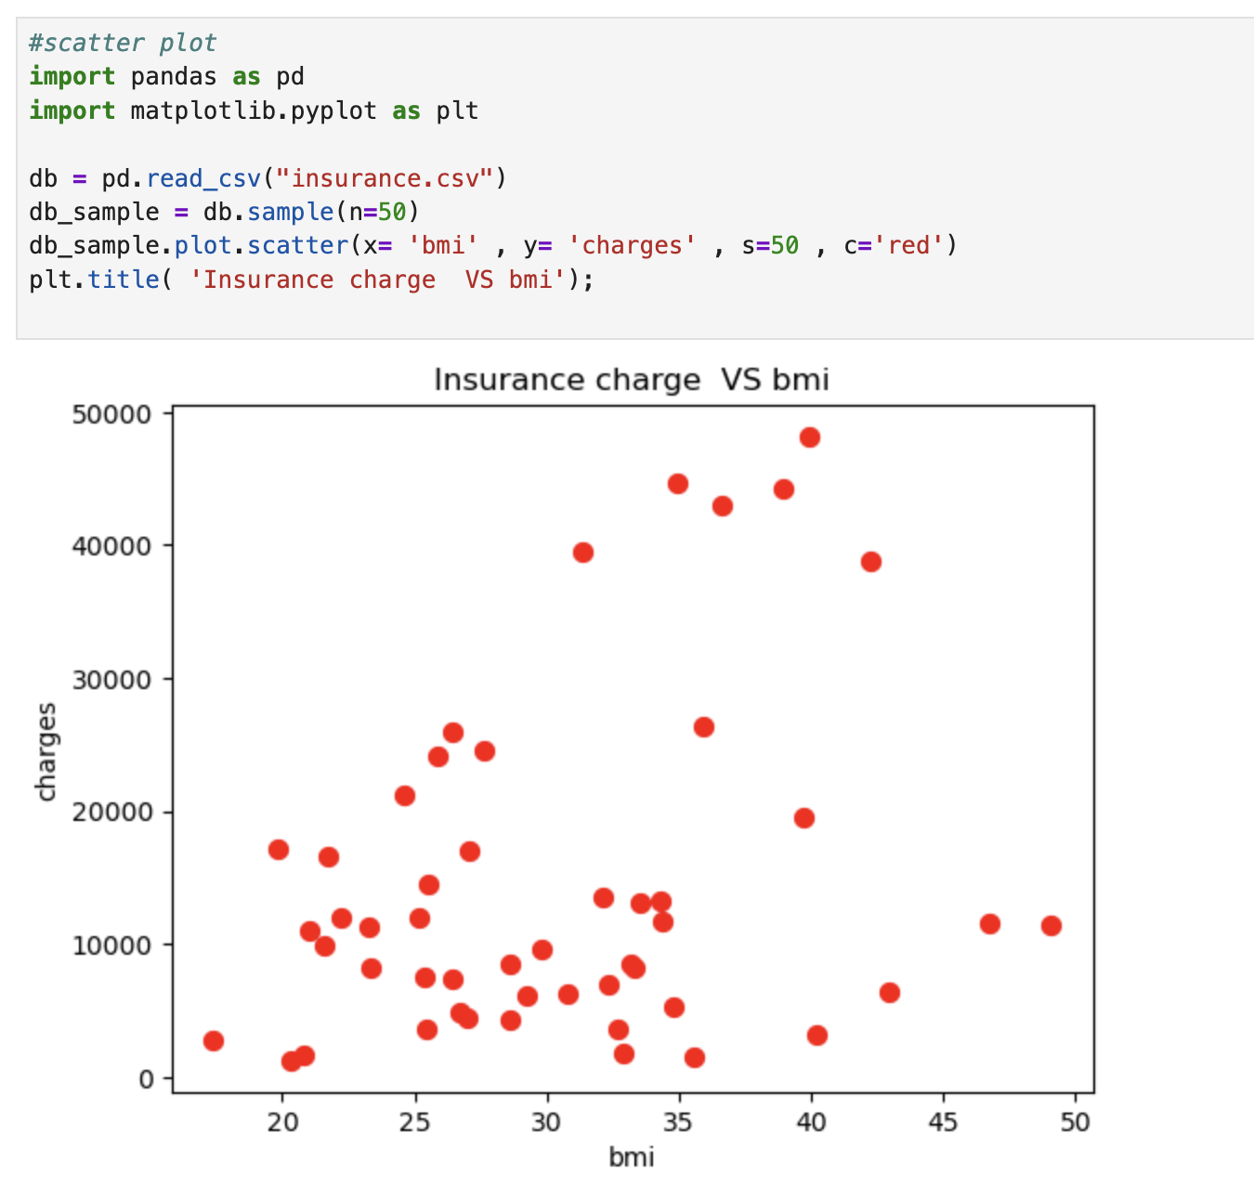

This scatter plot compares the insurance charges against the bmi , from the plot we can figure out the they have a weak positive relationship which means as the bmi increases the charges also increase

  - Box Plot
  - 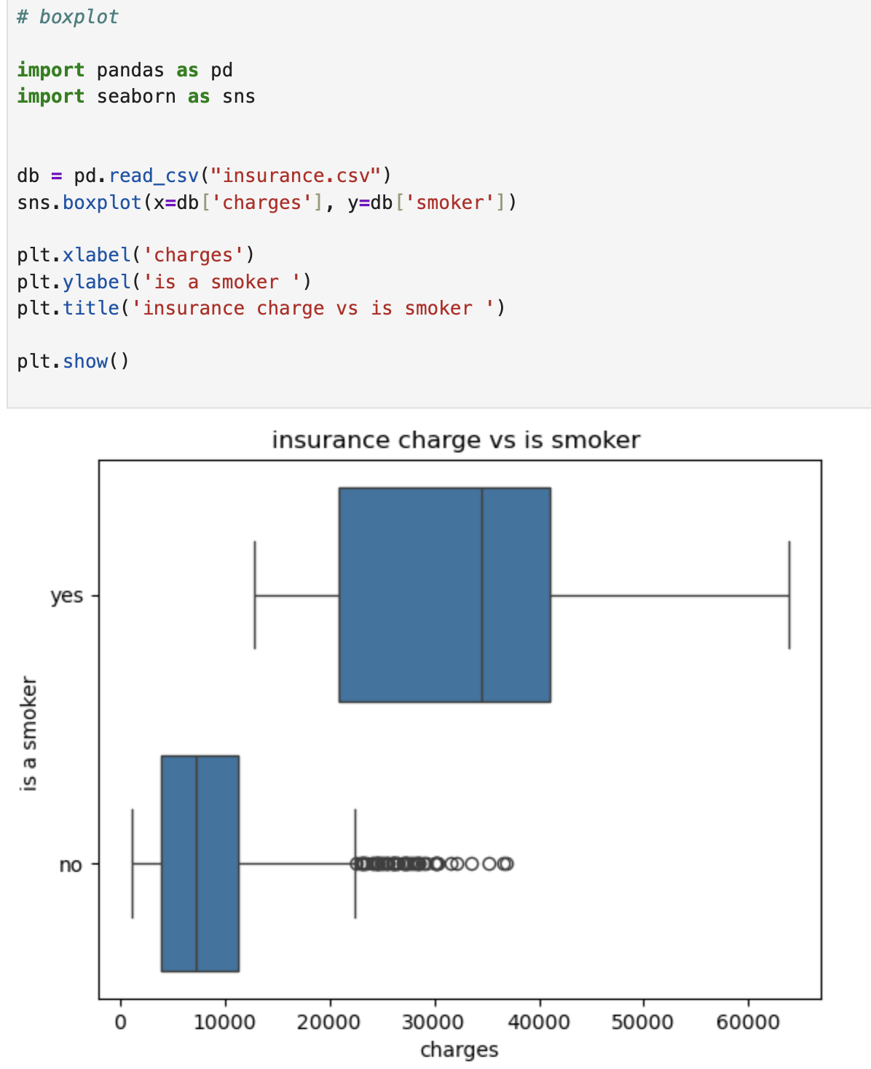
This boxplot compares the difference in insurance charges between a smoker and a non- smoker , from it we can tell that if a person smokes the insurance charges increase alot in comparison too a person that does not smoke

  - Histogram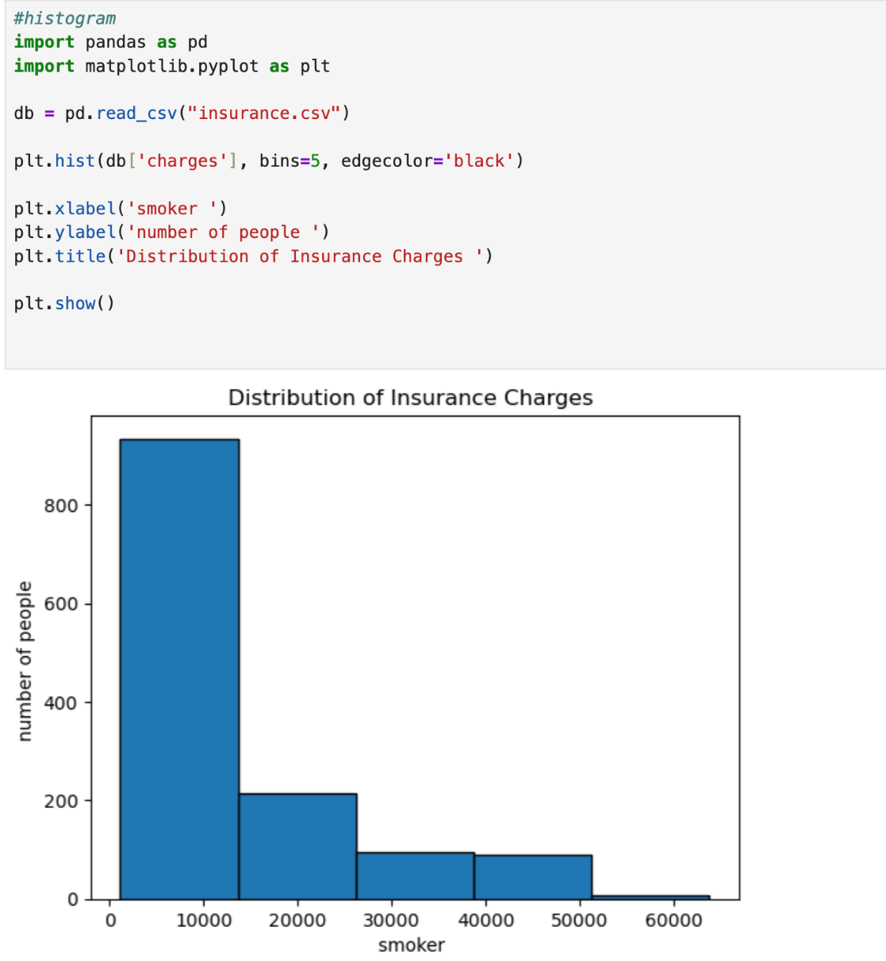
The distribution of insurance charges is right skrewed which tells us that most people are paying less than 15,000

  - Heat Map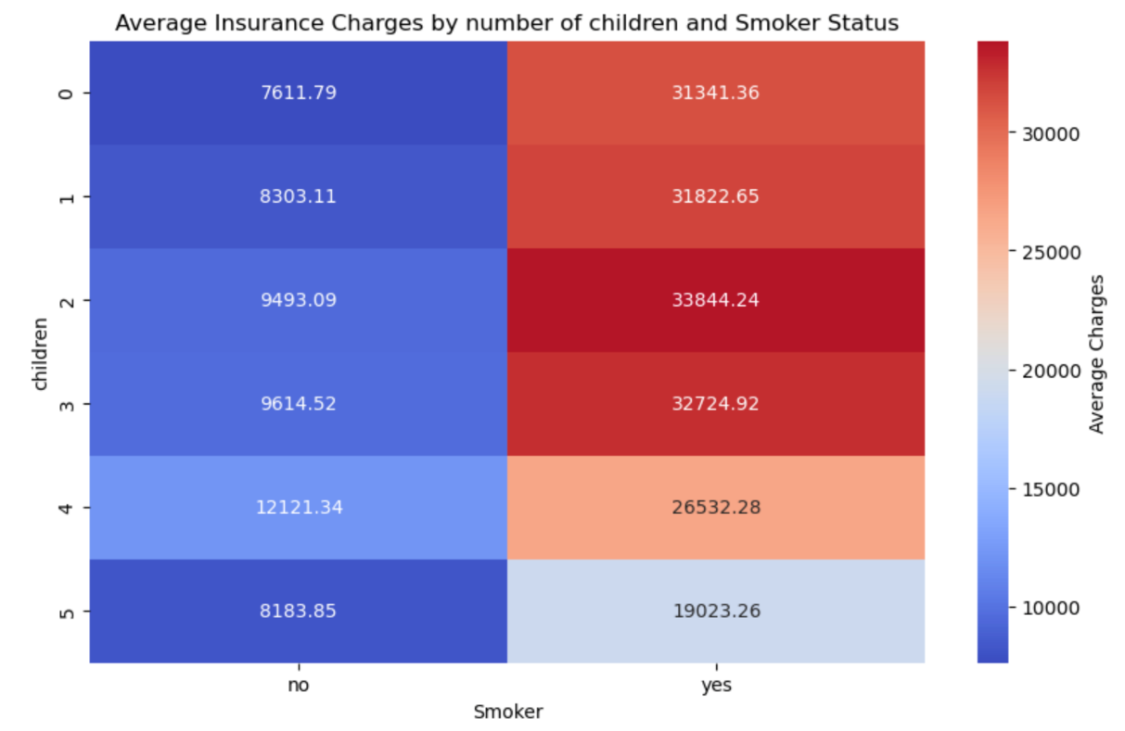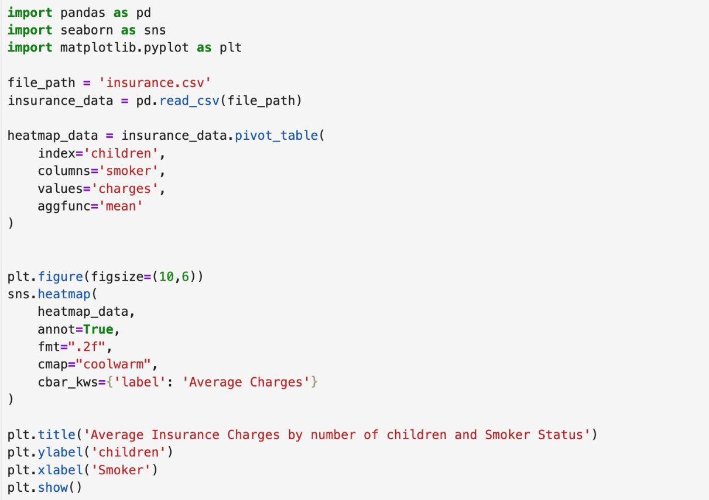
Hint: Use Matplot or Ski-learn library.>>

Hypothesis Test (1 point)
<< 8. Perform the hypothesis test to find the correlation (Pearson and Spearman for numerical variable and chi-square test for categorical variable) between the independent variable and the dependent variable
numerical value ( bmi )

.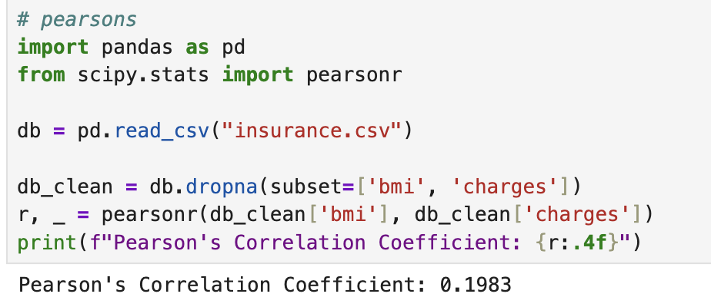
After conducting the persons correlation test we were able to figure out that the variables has a posistive correlation since persons test tells us that if the coefficient is between 0 and 1 it has a positive correlation and our coefficient is 0.198 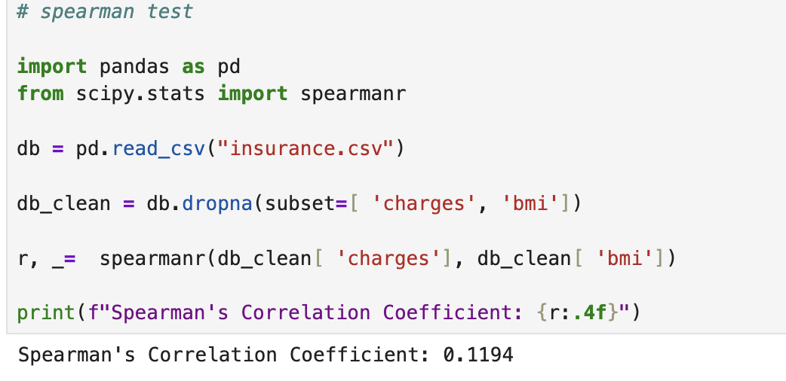
After conducting the spearmans correlation test the output tells us that the correlation between bmi and charges is a very weak positive relationship

categorical variable (smoker vs region)

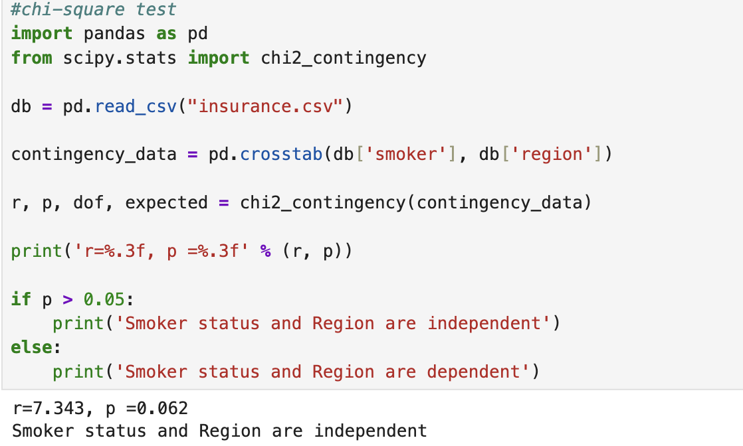
We chose two categorical variables smoker and region to check if there is a dependency after conducting the chi-square test we were able to figure out that their is no dependency

Note: If you have more than one independent variable, then choose any one of the independent variables..> >

One Sample T-test (2 points)
<< Assess the performance of the dependent variable to know whether the sample is representative of the normal population by a one-sample t-test..>>
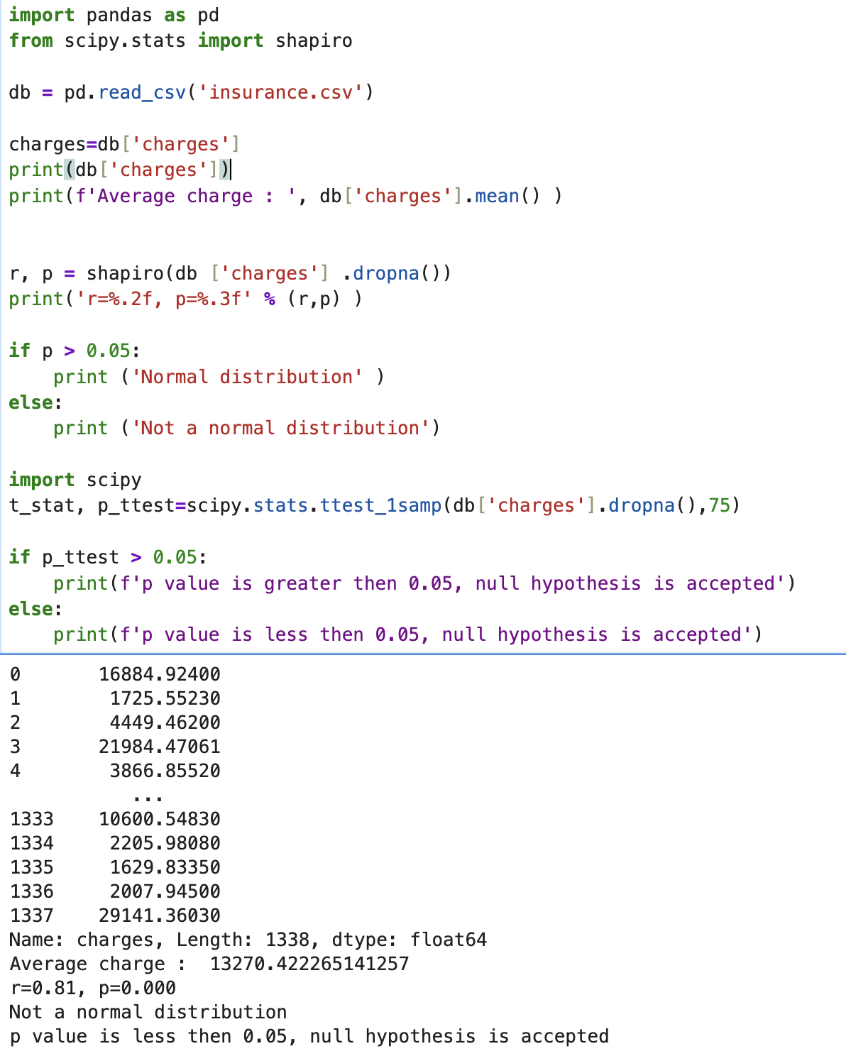

After conducting the one sample ttest we were able to figure out that the p value is less than 0.05 which means we fail to reject the null hypothesis
End of Documentation.

